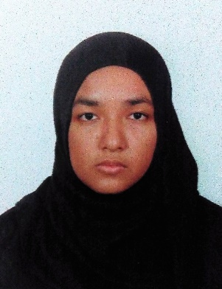
Yusrina Iazzate Bt Muhd Yunos
38, Jalan Bestari 23/3,
Taman Bestari Indah,
81800 Ulu Tiram, Johor
Phone: 017-7427124 Email: yusrinayunos94@gmail.com

CAREER OBJECTIVE
Seeking employment as a Graphic Designer to utilize skills with computers and the visual arts and illustrations for the mutual growth and success of your company with my academic knowledge and work experience gained through course of study and internship.

WORK EXPERIENCE
UI/UX Intern
Globaltium Sdn Bhd, 2015
- Positioned in IT department, designing some of the website content for company’s website and client’s website. Website and application user testing.
SKILLS
Adobe Illustrator | XXXXX | AutoCAD | XXXXX
Adobe Photoshop | XXXXX | Rhinoceros 5 | XXXXX
Adobe Dreamweaver | XXXXX | HTML 5 | XXXXX
Adobe Flash | XXXXX | CSS 3 | XXXXX
Adobe InDesign | XXXXX | Photography | XXXXX

EDUCATIONAL BACKGROUND
2013-2016 | Multimedia University  Bachelor of Multimedia (Hons) (Interface Design)  CGPA 3.37
2012-2013 | Multimedia University  Foundation in Creative Multimedia  CGPA 3.41
2007-2011 | MARA Junior Science College  SPM 7A 2B PMR 8A
LANGUAGE
English  Written: Excellent  Spoken: Good | Malay  Written: Good  Spoken: Excellent

PERSONAL QUALITIES
- Excellent communication skills
- Attention to details
- Fast learner
- Flexible

OTHER INVOLVEMENT
SOUL Carnival Volunteer (MMU) | Food division  - Serve VIPs dining
PGL Musical (MMU) | Technical team  - In charge of music and sounds control
Volleyball League (MMU) | Registration  - Handles fees and team registration invoices
Karnival SRM (MMU) | Photoshop facilitator  - Helps participants throughout learning process
Spartan Challenge (MMU) | Technical team  - Creating playlist of songs for running event with team members and handling equipment

REFERENCES
Mr. Zainudin Bin Siran  Academic advisor  zainudin.siran@mmu.edu.my | Mrs. Wong Chui Yin  Senior Lecturer  cywong@mmu.edu.my

Online portfolio at https://www.behance.net/yuhost

